BREAST CANCER DETECTION USING MACHINE LEARNING

A Project Report

Submitted by:
Rajaram Parida (2241016203)
Saswat Parida (2241016206)
Manpreet Mohanty (2241013252)
Adyasha Biswal (2241002197)
in partial fulfillment for the award of the degree
of
BACHELOR OF TECHNOLOGY
IN
COMPUTER SCIENCE AND ENGINEERING


DEPARTMENT OF COMPUTER SCIENCE AND ENGINEERING
Faculty of Engineering and Technology, Institute of Technical Education and Research
SIKSHA ‘O’ ANUSANDHAN (DEEMED TO BE) UNIVERSITY
Bhubaneswar, Odisha, India
(June 2026)



CERTIFICATE

This is to certify that the project report titled "Breast Cancer Detection Using Machine Learning" being submitted by Rajaram Parida (2241016203), Saswat Parida (2241016206), Manpreet Mohanty (2241013252), and Adyasha Biswal (2241002197) to the Institute of Technical Education and Research, Siksha 'O' Anusandhan (Deemed to be) University, Bhubaneswar for the partial fulfillment for the degree of Bachelor of Technology in Computer Science and Engineering is a record of original bonafide work carried out by them under my supervision and guidance. The project work, in my opinion, has reached the requisite standard fulfilling the requirements for the degree of Bachelor of Technology.
The results contained in this project work have not been submitted in part or full to any other University or Institute for the award of any degree or diploma.

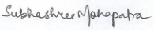
(Dr. Subhashree Mohapatra)
Project Supervisor
Department of Computer Science and Engineering
Faculty of Engineering and Technology;
Institute of Technical Education and Research;
Siksha ‘O’ Anusandhan (Deemed to be) University

ACKNOWLEDGEMENT

We would like to express our sincere gratitude to our project supervisor, Dr. Subhashree Mohapatra, for her invaluable guidance, continuous encouragement, and constructive feedback throughout the course of this project. Her expertise and insights have been instrumental in shaping this work.

We extend our thanks to the Department of Computer Science and Engineering, Institute of Technical Education and Research, Siksha 'O' Anusandhan (Deemed to be) University, for providing the necessary facilities and resources that made this project possible.

We are also grateful to our family and friends for their unwavering support and motivation throughout our academic journey.








Place: Bhubaneswar Signature of Students

Date: June 2026

DECLARATION

We declare that this written submission represents our ideas in our own words and where other's ideas or words have been included, we have adequately cited and referenced the original sources. We also declare that we have adhered to all principles of academic honesty and integrity and have not misrepresented or fabricated or falsified any idea/fact/source in our submission. We understand that any violation of the above will cause for disciplinary action by the University and can also evoke penal action from the sources which have not been properly cited or from whom proper permission has not been taken when needed.

Rajaram Parida (2241016203)

Saswat Parida (2241016206)

Manpreet Mohanty (2241013252)

Adyasha Biswal (2241002197)
Signature of Students with Registration Numbers
Date: June 2026

REPORT APPROVAL

This project report titled “Breast Cancer Detection Using Machine Learning“ submitted by Rajaram Parida (2241016203), Saswat Parida (2241016206), Manpreet Mohanty (2241013252), and Adyasha Biswal (2241002197) is approved for the degree of Bachelor of Technology in Computer Science and Engineering.

Examiner(s)

________________________
________________________
________________________

Supervisor

________________________

Project Coordinator

________________________

PREFACE

Breast cancer remains one of the leading causes of mortality among women worldwide, making early and accurate detection critical for successful treatment outcomes. This project investigates the application of multiple machine learning algorithms for breast cancer classification using the Wisconsin Breast Cancer Dataset, which comprises 569 samples with 30 numerical features derived from digitized images of fine needle aspirate (FNA) biopsies.

The study evaluates four distinct modeling approaches: Support Vector Machine (SVM) with linear, RBF, and polynomial kernels; Random Forest with Gini and Entropy splitting criteria; Stacking Ensemble with tree-based and linear-based base learners; and a Voting Ensemble combining XGBoost, Random Forest, and SVM. Each model is tested under four data conditions: raw imbalanced data, SMOTE-balanced data, increased data with 500 samples per class, and hyperparameter-tuned configurations. Additionally, the impact of train-test split ratios (90/10, 80/20, 70/30, and 60/40) is analyzed.

All models are evaluated using six standard metrics: Accuracy, Precision, Recall, F1-Score, Specificity, and AUC-ROC. The results demonstrate that ensemble methods outperform individual classifiers, with the XGBoost-RF-SVM Voting Ensemble achieving the highest performance of 99% accuracy on a 90/10 split. The Stacking Ensemble with linear base learners also showed strong performance at 99% accuracy. Feature importance analysis using SHAP (SHapley Additive exPlanations) provides interpretability by identifying the most influential features in the classification decision.

Keywords: Breast Cancer Detection, Machine Learning, SVM, Random Forest, Stacking Ensemble, XGBoost, SMOTE, SHAP

INDIVIDUAL CONTRIBUTIONS

Rajaram Parida | Literature survey; problem formulation and solution design; implementation of SVM, Voting Ensemble, and SHAP; hyperparameter tuning and ratio analysis experiments; Streamlit application development; report and manuscript writing; documentation
Saswat Parida | Literature survey; identification of problem statement; implementation of Random Forest models; dataset preprocessing, augmentation, and balancing; result analysis; documentation
Manpreet Mohanty | Literature survey; implementation of Stacking Ensemble models; hyperparameter tuning and ratio experiments; visualization design and result analysis; documentation
Adyasha Biswal | Literature survey; result validation and comparative analysis; evaluation metrics computation; report compilation and formatting; documentation

TABLE OF CONTENTS
 | Title Page | i
 | Certificate | ii
 | Acknowledgement | iii
 | Declaration | iv
 | Report Approval | v
 | Preface | vi
 | Individual Contributions | vii
 | Table of Contents | viii
 | List of Figures | ix
 | List of Tables (optional) | x
1. | INTRODUCTION | 1
 | - Project Overview  - Motivations  - Uniqueness of the Work  - Report Layout | 1  1  2  2
2. | LITERATURE SURVEY | 3
 | 2.1 Review of Existing Systems / Related Work  2.2 Research Gaps Identified  2.3 Problem Identification | 3  4  4
3. | MATERIALS AND METHODS | 5
 | 3.1 Dataset(s) Description  3.2 Schematic Layout/Model Diagram  3.3 Methodologies Adopted  3.4 Tools Used  3.5 Experimental Setup  3.6 Evaluation Metrics and Performance Measures | 5  6  6  7  7  8
4. | RESULTS  4.1 System Specification  4.2 Parameters and Configuration Settings  4.3 Experimental Results and Observations  4.4 Performance Analysis  4.5 Comparative Study and Discussion | 9  9  9  10  18  19
5. | CONCLUSIONS | 20
6. | REFERENCES | 22
7. | APPENDICES | 24
8. | REFLECTION OF THE TEAM MEMBERS ON THE PROJECT | 26
9. | SIMILARITY REPORT | 28

LIST OF FIGURES

NO | FIGURE NAME | PAGE NO
1 | Best Accuracy by Kernel, SVM | 10
2 | Best Accuracy by Train/Test Split, SVM | 12
3 | Accuracy Comparison across models | 12
4 | AUC‑ROC Comparison | 14
5 | Precision Comparison | 15
6 | Recall Comparison | 16
7 | F1‑Score Comparison | 17

LIST OF TABLES

NO | TABLE NAME | PAGE NO
1 | Performance Metrics of Support Vector Machine Variants across Different Dataset Types | 11
2 | Performance Metrics of Support Vector Machine Variants across Different Train/Test Split | 11
3 | Performance Metrics of Random Forest Variants across Different Dataset Types | 13
4 | Performance Metrics of Random Forest Variants across Different Train/Test Split | 13
5 | Performance Metrics of Stacked Ensemble Variants across Different Dataset Types | 14
6 | Performance Metrics of Stacked Ensemble Variants across Different Train/Test Split | 15
7 | Performance Metrics of XGBoost-RF-SVM Ensemble Variants across Different Train/Test Split | 17

CHAPTER 1: INTRODUCTION

1.1 Project Overview

Breast cancer is a serious condition that develops when abnormal cells in the breast start multiplying in an uncontrolled way, eventually forming a tumor. It is among the most frequently diagnosed cancers in women worldwide. The World Health Organization reports that around 2.3 million new cases are recorded each year globally. Catching it early makes a huge difference early detection often means treatment can begin sooner, improving the chances of survival and helping to keep the disease from spreading further.
Machine learning has quietly become a big part of medical diagnosis, mainly because it can pick up patterns in data that are often too subtle or complex for manual analysis. In breast cancer studies, it’s especially useful for improving both the accuracy and speed of detection.
A widely used benchmark in this area is the Wisconsin Breast Cancer Dataset, created by Dr. William H. Wolberg at the University of Wisconsin Hospitals. It includes data from 569 patients and provides 30 numerical features taken from digitized images of fine needle aspirate (FNA) biopsy samples. Each case is labeled as either benign or malignant.
Because the dataset is clean, well-organized, and trusted by researchers, it’s often used as a standard reference point for testing and comparing different machine learning models in medical research.
The goal of this project is to build and compare different machine learning models to classify breast cancer tumors as either benign or malignant. It looks at how various algorithms perform under different preprocessing techniques and experimental settings, with the aim of finding which approach gives the most accurate and dependable results.
By testing these methods in a structured way, the project tries to narrow down a model that performs well enough to support early detection and can realistically assist in clinical decision-making.

1.2 Motivations

The primary motivations for this project include:
This project is motivated by a few key concerns in healthcare, especially the need for diagnostic systems that are both accurate and reliable. In medical settings, the cost of mistakes can be serious classifying a malignant tumor as benign can delay treatment and lower the chances of recovery, while a false alarm can create unnecessary stress and lead to extra tests or procedures that might not be needed.
Because of this, it becomes especially important to focus not just on overall accuracy, but on correctly identifying malignant cases as consistently as possible. High recall for malignant tumors, in particular, is critical in breast cancer detection, where early and correct diagnosis can make a real difference in outcomes.
Another reason behind this project is to explore and compare different machine learning methods using a well-established, standardized dataset. It takes a closer look at models like Support Vector Machine (SVM), Random Forest, a Stacking Ensemble, and a Voting Ensemble that brings together XGBoost, Random Forest, and SVM.
By putting these techniques side by side, the idea is to get a clearer sense of which approaches tend to perform better and feel more reliable when it comes to medical classification tasks like this.
The project also looks into more advanced machine learning techniques that help improve both how well the models perform and how understandable their decisions are. For example, SMOTE is used to handle the imbalance in the dataset, while SHAP analysis is applied to make sense of how different features are actually influencing the model’s predictions.
On top of that, hyperparameter tuning is carried out to push the models toward better accuracy and overall performance. These kinds of methods aren’t limited to breast cancer detection they’re widely useful across many real-world machine learning problems where both accuracy and interpretability matter.

1.3 Uniqueness of the Work

This project distinguishes itself through several key contributions:
- A thorough evaluation of four different machine learning approaches SVM, Random Forest, Stacking, and Voting Ensemble carried out under the same experimental conditions for a fair comparison.
- A structured comparison across four different data conditions raw, balanced, increased, and tuned to better understand how each setup influences model performance.
- Evaluation of four different train-test split ratios to see how changes in the amount of training data affect overall model performance.
- Incorporation of SHAP explanations to improve model interpretability, making it easier to understand which features are actually influencing the classification decisions.
- A consistent blue-themed visualization style used across all experiments, helping make the results clearer and easier to compare at a glance.

1.4 Report Layout
The rest of this report is organized as follows. Chapter 2 looks at existing literature and earlier research on breast cancer detection using machine learning methods.
Chapter 3 then walks through the materials and methods used in this study, covering the dataset, model architectures, evaluation metrics, and the overall experimental setup.
Chapter 4 focuses on the results, presenting what came out of the experiments along with a comparison of all models and the different testing conditions.
Finally, Chapter 5 wraps everything up with the main findings and suggests a few possible directions for future work and improvement.

CHAPTER 2: LITERATURE SURVEY

2.1 Review of Existing Systems / Related Work

Machine learning has been used extensively for breast cancer diagnosis, especially with datasets like the Wisconsin Breast Cancer Dataset. An early study by Street et al. (1993) highlighted that features extracted from medical images could be effectively used to distinguish between different types of breast tumors. Their work helped establish the potential of machine learning in healthcare, reporting an accuracy of over 95% using a decision tree–based method.

Support Vector Machines have also been extensively explored for this problem. Akay (2009) achieved a classification accuracy of 98.53% using SVM combined with a feature selection technique. In a similar study, Osareh and Shadgar (2010) evaluated SVM against other classifiers on the WDBC dataset and concluded that it performed better overall, reaching an accuracy of 98.8%.

Random Forest classifiers have also demonstrated strong results in this area. Wu et al. (2012) used Random Forest for breast cancer diagnosis and achieved an accuracy of 98.2%. They also noted that the ensemble structure of the model helps improve robustness and reduces the risk of overfitting.

Ensemble methods have increasingly gained attention because they combine the strengths of multiple classifiers into a single, more robust model. In stacking approaches, for example, a meta-learner is trained on the outputs of several base models, which often leads to better performance than relying on any one model alone. Polat and Gunes (2007) also showed that ensemble techniques can achieve higher accuracy than individual classifiers in breast cancer detection tasks.

More recently, XGBoost has become widely recognized as a powerful gradient boosting framework for machine learning tasks. Chen and Guestrin (2016) showed that it often outperforms many traditional algorithms, particularly when dealing with structured datasets. Because of this, it has also proven to be a strong fit for medical problems, including applications like the Wisconsin Breast Cancer dataset.

In addition to this, researchers have also looked into hybrid approaches that bring XGBoost together with other classifiers in ensemble setups like voting models. These combined systems have shown promising results, often improving both accuracy and stability compared to using a single model on its own.

2.2 Research Gaps Identified

While a good amount of research has already been done on individual machine learning classifiers for breast cancer detection, there are still some noticeable gaps in the existing work. One major limitation is that many studies evaluate models under just one data setting—often either raw or balanced data—without really comparing how different preprocessing methods affect performance in a more systematic way.
Another common gap is that very few studies take a deeper look at how different train-test split ratios actually affect results. In most cases, researchers stick to a single fixed split—often 80/20—which makes it harder to understand how sensitive a model really is to changes in how the data is divided.
Finally, interpretability often doesn’t get the attention it deserves. Methods like SHAP, which can explain model predictions and highlight feature importance, are rarely included alongside performance comparisons. Because of this, many studies focus only on how well models perform, without really showing why they are making certain predictions in the first place.

2.3 Problem Identification

Based on the existing literature, this project is centered around a key question: how do different machine learning algorithms perform on the Wisconsin Breast Cancer Dataset, and how do they compare when it comes to classification effectiveness?
Specifically, this study looks at and compares several models, including Support Vector Machine (SVM), Random Forest, a Stacking Ensemble, and a Voting Ensemble that combines XGBoost, Random Forest, and SVM. The aim is to evaluate how well each of them classifies tumors as benign or malignant and to figure out which approach turns out to be the most reliable for this problem.
Along with that, the project also looks at how model performance shifts under different experimental setups. This involves changing things like data preprocessing methods, tuning hyperparameters, and trying out different train-test split ratios. By exploring these variations, the study tries to build a clearer, more complete picture of how the models behave and how stable they really are across different conditions.

CHAPTER 3: MATERIALS AND METHODS

3.1 Dataset Description

The Wisconsin Breast Cancer Dataset (WDBC), available from the UCI Machine Learning Repository, is widely used as a benchmark for testing classification models in medical research. It contains 569 samples, with each one described using 30 continuous features extracted from digitized images of fine needle aspirate (FNA) biopsy results.
The dataset is divided into two diagnostic classes: benign tumors, which account for 357 cases (around 62.7%), and malignant tumors, with 212 cases (about 37.3%). This imbalance between the classes can create challenges for machine learning models, since they may become biased toward the majority class if it isn’t properly handled.
To deal with this, methods like SMOTE (Synthetic Minority Over-sampling Technique) are commonly used to create additional synthetic samples for the minority class. This helps balance the dataset and generally leads to more stable and reliable classification performance.
The dataset contains 30 numerical features that capture different characteristics of cell nuclei extracted from fine needle aspirate (FNA) images. These features are organized into three main groups.
The first group includes the mean values, which capture the average measurements of features like radius, texture, perimeter, area, smoothness, compactness, concavity, concave points, symmetry, and fractal dimension.
The second group consists of standard error values, which reflect how much variation or uncertainty exists in the same set of features. This includes radius_se, texture_se, perimeter_se, area_se, smoothness_se, compactness_se, concavity_se, concave points_se, symmetry_se, and fractal_dimension_se.
The third group includes the “worst” values, which reflect the most extreme measurements recorded for each feature. This covers attributes such as radius_worst, texture_worst, perimeter_worst, area_worst, smoothness_worst, compactness_worst, concavity_worst, concave points_worst, symmetry_worst, and fractal_dimension_worst. These values often highlight the most pronounced characteristics of a tumor, which can be especially useful for improving classification accuracy.

This project uses three different versions of the dataset for experimentation and comparison.
- The raw dataset contains 569 samples, with 357 benign cases and 212 malignant cases.
- A balanced dataset generated using SMOTE, containing 714 samples with 357 benign and 357 malignant cases.
- An expanded dataset created using SMOTE, with 500 samples per class, resulting in a total of 1000 samples.

3.2 Schematic Layout / Model Diagram

The overall experimental workflow is organized into a series of clearly defined stages:
1. Data acquisition and preprocessing, which includes removing the ID column, encoding the class labels, and handling any missing values.
2. Feature standardization using StandardScaler to bring all features onto a common scale.
3. Train-test splitting, starting with an 80/20 ratio by default and further experimenting with 90/10, 70/30, and 60/40 splits to observe how performance changes.
4. Model training, where four different models are developed and tested under various configurations.
5. Model Evaluation (six metrics)
6. Visualization (confusion matrix heatmap, metrics bar chart, ROC curve)
7. Interpretability (SHAP feature importance analysis for the Voting Ensemble)

3.3 Methodologies Adopted

Four machine learning models are implemented and evaluated:
A. Support Vector Machine (SVM): SVM builds a hyperplane in a high-dimensional space to separate the two classes as clearly as possible. Three kernels are tested: linear, RBF, and polynomial. The regularization parameter C is tuned using GridSearchCV with values [0.1, 1, 10].
B. Random Forest: Random Forest is an ensemble of decision trees trained on bootstrapped samples with random feature selection at each split. Gini impurity and entropy are used as splitting criteria. The number of trees (n_estimators) and maximum depth (max_depth) are tuned for best performance.
C. Stacking Ensemble: Stacking combines multiple base classifiers and trains a meta-classifier on their predictions. Two configurations are tested: tree-based base learners (RandomForest, ExtraTrees, GradientBoosting) with LogisticRegression as meta-learner, and linear-based base learners (LogisticRegression, SVM-linear, SGDClassifier) with LogisticRegression as meta-learner.
D. XGBoost-RF-SVM Voting Ensemble: This ensemble uses soft voting (weighted probability averaging) across three diverse classifiers: XGBoost (gradient boosting), Random Forest (bagging), and SVM (margin-based). SHAP (SHapley Additive exPlanations) is applied using the XGBoost component to identify feature importance.

3.4 Tools Used

The project is developed in Python using the following key libraries:
- scikit-learn for implementing models such as SVM, Random Forest, Stacking Ensemble, and evaluation metrics
- XGBoost for gradient boosting-based classification
- SHAP for explaining model predictions
- imbalanced-learn for handling class imbalance using SMOTE
- pandas and NumPy for data processing and manipulation
- Matplotlib and Seaborn for data visualization
- Streamlit for building the interactive web application interface

3.5 Experimental Setup

All experiments are carried out using the following setup:
- The random state is set to 42 so that the results remain consistent and reproducible across different runs.
- Stratified train-test splitting is applied to ensure that both the training and testing sets maintain the same class distribution, keeping the data balanced across splits.
- Hyperparameter tuning is carried out using GridSearchCV, along with 5-fold cross-validation to ensure more reliable and stable model selection.
- The default train-test split is set to 80/20, with additional experiments conducted using 90/10, 70/30, and 60/40 ratios to analyze how performance changes across different data partitions.
- Feature scaling is performed using StandardScaler, with the scaling parameters learned exclusively from the training data to prevent any data leakage.

Each model is tested under four different data conditions to better understand its performance across varying setups:
1. Raw (imbalanced) - 569 samples
2. Balanced - 714 samples (SMOTE)
3. Increased dataset (expanded size), containing 1000 samples created using SMOTE with 500 samples per class.
4. Tuned dataset setup, where the increased data is further optimized using hyperparameter tuning to improve model performance.

3.6 Evaluation Metrics and Performance Measures

The models are evaluated using six commonly used performance metrics.
- Accuracy = (TP + TN) / (TP + TN + FP + FN)
This measures the overall proportion of correct predictions made by the model.
- Precision = TP / (TP + FP)
This shows how many of the cases predicted as positive are actually correct.
- Recall (Sensitivity) = TP / (TP + FN)
This represents the proportion of actual positive cases that are correctly identified by the model.
- F1-Score = 2 × (Precision × Recall) / (Precision + Recall)
This gives a balanced view of the model’s performance by combining both precision and recall into a single metric.
- Specificity = TN / (TN + FP)
This measures how effectively the model correctly identifies negative cases.
- AUC-ROC
This represents the area under the Receiver Operating Characteristic (ROC) curve and shows how well the model can distinguish between the two classes across different classification thresholds.
Here, TP refers to True Positives, TN to True Negatives, FP to False Positives, and FN to False Negatives.

CHAPTER 4: RESULTS

4.1 System Specification

The experiments were conducted on a system with the shown specs:
- Operating System: Windows 11
- Processor: Intel Core series processor
- Memory (RAM): 8 GB or more, providing enough capacity to handle machine learning tasks efficiently
- Python Version: 3.10 or above
- Development Environment: Visual Studio Code and Jupyter Notebook

4.2 Parameters and Configuration Settings

The following hyperparameter grids were defined and used for GridSearchCV.
- SVM (Linear kernel): C values = [0.1, 1, 10]
- SVM (RBF kernel): C values set to [0.1, 1, 10], with gamma parameters tested as ['scale', 'auto'].
- SVM (Polynomial kernel): C values = [0.1, 1, 10], degree = [2, 3, 4]
- Random Forest: n_estimators = [50, 100, 200], max_depth = [5, 10, None]
- Stacking Ensemble: final_estimator__C = [0.1, 1, 10]
- XGBoost (within Voting Ensemble): n_estimators = [50, 100, 200], max_depth = [3, 5, 7]

4.3 Experimental Results and Observations

4.3.1 SVM Results
SVM was tested using three different kernels across all data conditions. On the raw dataset, the RBF kernel consistently gave the best results, reaching 97.37% accuracy and 92.86% recall, outperforming both the linear and polynomial variants. The polynomial kernel, however, struggled on raw data, with much lower performance (88.6% accuracy and 69.05% recall), though it improved noticeably once the data was balanced, achieving 98.6% accuracy and 98.59% recall. Overall, hyperparameter tuning led to only slight gains across all kernel types.

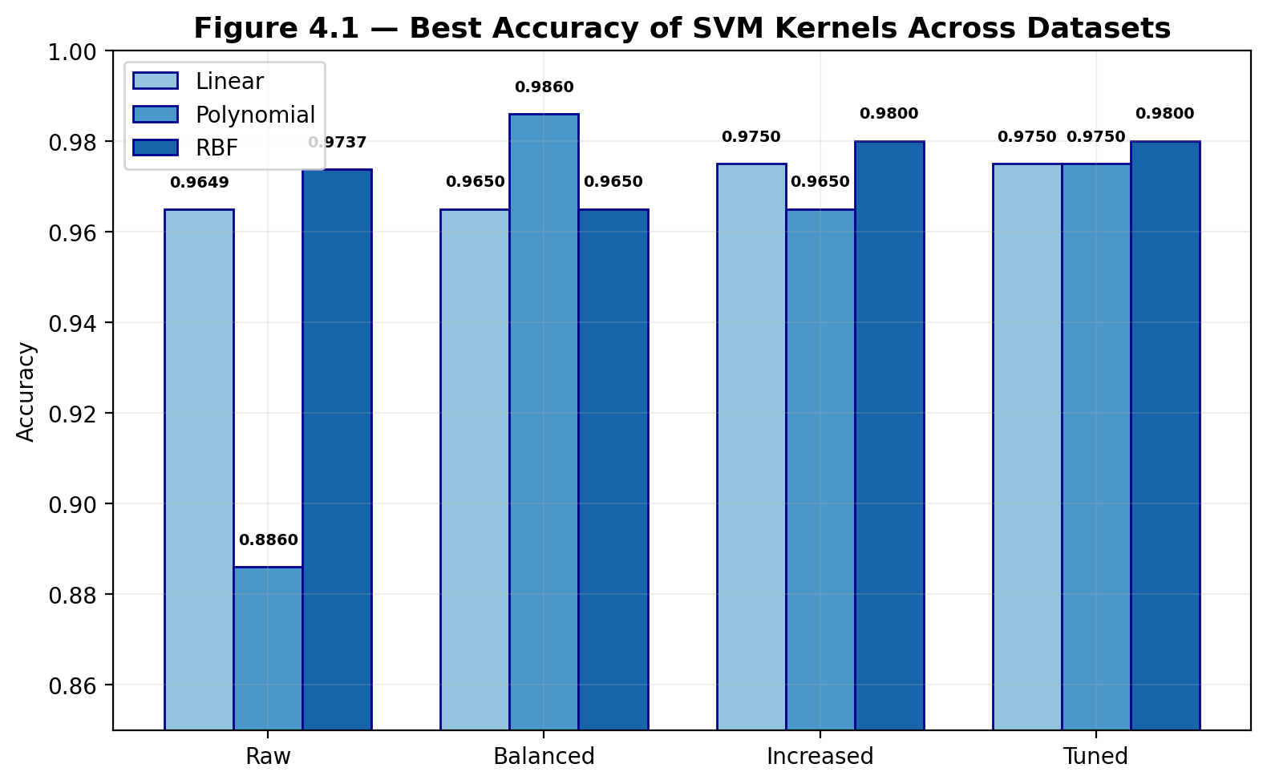

Performance Summary for SVM (80/20 split):
Model Variant | Kernel | Dataset | Accuracy | Precision | Recall | F1-Score | Specificity | AUC-ROC
SVM | Linear | Increased Size | 0.975 | 0.9897 | 0.96 | 0.9746 | 0.99 | 0.9974
SVM | Polynomial | Increased Size | 0.965 | 0.9794 | 0.95 | 0.9645 | 0.98 | 0.9914
SVM | RBF | Increased Size | 0.98 | 1 | 0.96 | 0.9796 | 1 | 0.9946
SVM | Linear | Balanced | 0.965 | 0.9714 | 0.9577 | 0.9645 | 0.9722 | 0.9939
SVM | Polynomial | Balanced | 0.986 | 0.9859 | 0.9859 | 0.9859 | 0.9861 | 0.9992
SVM | RBF | Balanced | 0.965 | 0.9853 | 0.9437 | 0.964 | 0.9861 | 0.9963
SVM | Linear | Tuned | 0.975 | 1 | 0.95 | 0.9744 | 1 | 0.9946
SVM | Polynomial | Tuned | 0.975 | 1 | 0.95 | 0.9744 | 1 | 0.9984
SVM | RBF | Tuned | 0.98 | 1 | 0.96 | 0.9796 | 1 | 0.9983
SVM | Linear | Raw | 0.9649 | 1 | 0.9048 | 0.95 | 1 | 0.9914
SVM | Polynomial | Raw | 0.886 | 1 | 0.6905 | 0.8169 | 1 | 0.9967
SVM | RBF | Raw | 0.9737 | 1 | 0.9286 | 0.963 | 1 | 0.9947
Table 1: Performance Metrics of SVM Variants across Different Dataset Types

Performance Summary for SVM (different ratios):
Model Variant | Kernel | Train/Test Split | Accuracy | Precision | Recall | F1-Score | Specificity | AUC-ROC
SVM | Linear | 90/10 | 0.99 | 1 | 0.98 | 0.9899 | 1 | 0.9976
SVM | Linear | 80/20 | 0.975 | 0.9897 | 0.96 | 0.9746 | 0.99 | 0.9974
SVM | Linear | 70/30 | 0.9668 | 0.9861 | 0.9467 | 0.966 | 0.9868 | 0.994
SVM | Linear | 60/40 | 0.975 | 0.9897 | 0.96 | 0.9746 | 0.99 | 0.9951
SVM | Polynomial | 90/10 | 0.97 | 0.9796 | 0.96 | 0.9697 | 0.98 | 0.9908
SVM | Polynomial | 80/20 | 0.965 | 0.9794 | 0.95 | 0.9645 | 0.98 | 0.9914
SVM | Polynomial | 70/30 | 0.9601 | 0.9726 | 0.9467 | 0.9595 | 0.9735 | 0.9883
SVM | Polynomial | 60/40 | 0.9625 | 0.9695 | 0.955 | 0.9622 | 0.97 | 0.9912
SVM | RBF | 90/10 | 0.99 | 1 | 0.98 | 0.9899 | 1 | 0.9976
SVM | RBF | 80/20 | 0.98 | 1 | 0.96 | 0.9796 | 1 | 0.9946
SVM | RBF | 70/30 | 0.9734 | 1 | 0.9467 | 0.9726 | 1 | 0.9913
SVM | RBF | 60/40 | 0.975 | 0.9948 | 0.955 | 0.9745 | 0.995 | 0.9922
Table 2: Performance Metrics of SVM Variants across Different Train/Test Split

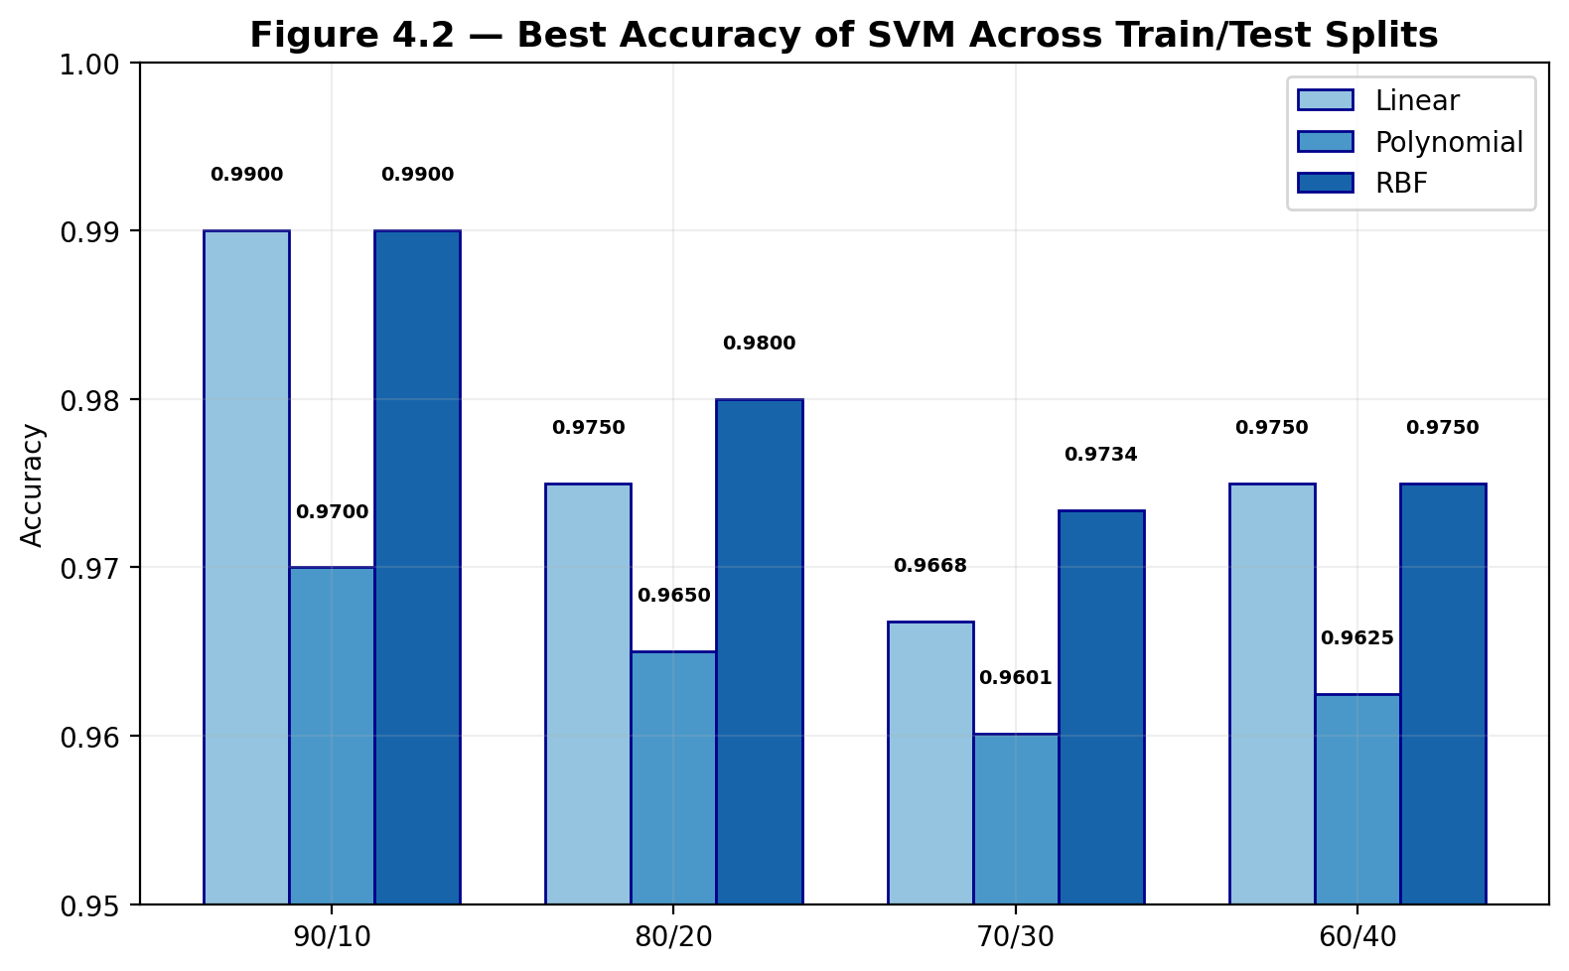

4.3.2 Random Forest Results
The Random Forest model showed consistent and dependable performance using both the Gini impurity and Entropy criteria. On the raw dataset, both settings achieved an accuracy of 97.37%, while performance improved slightly on the increased dataset, reaching 97.5%.
When evaluated on the balanced dataset, the Gini criterion achieved a marginally higher accuracy of 97.9% compared to 97.2% for Entropy. Across raw and balanced settings, both versions consistently maintained perfect precision (1.000), indicating that no false positive predictions were made in these cases.
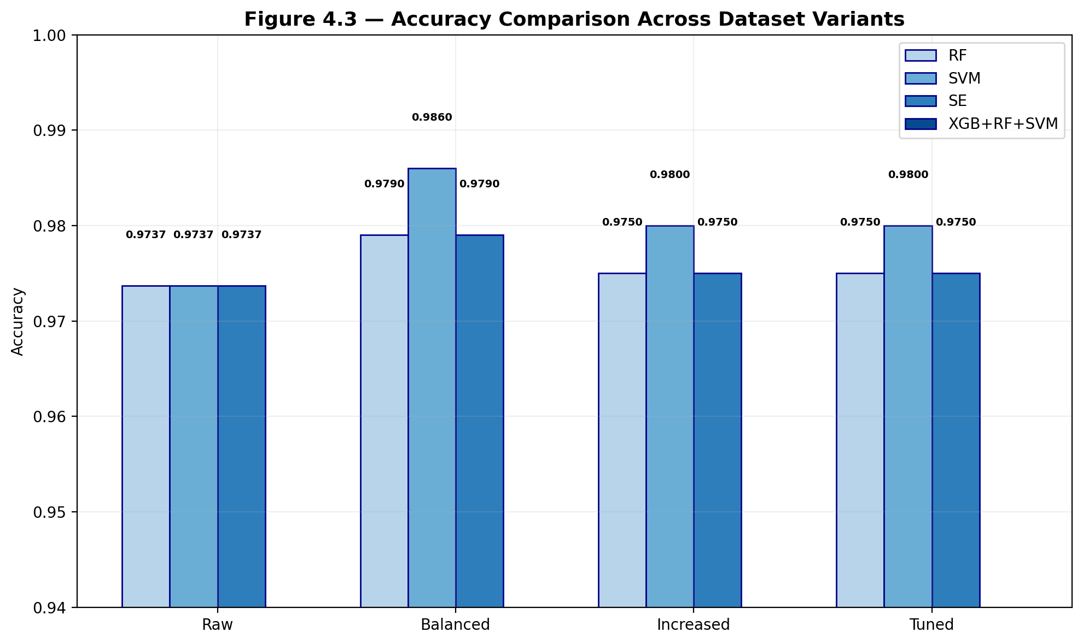
Performance Summary for Random Forest (80/20 split):
Model Variant | Kernel | Dataset | Accuracy | Precision | Recall | F1-Score | Specificity | AUC-ROC
RF | Entropy | Increased Size | 0.975 | 1 | 0.95 | 0.9744 | 1 | 0.9962
RF | Gini | Increased Size | 0.975 | 1 | 0.95 | 0.9744 | 1 | 0.9956
RF | Entropy | Balanced | 0.972 | 1 | 0.9437 | 0.971 | 1 | 0.9986
RF | Gini | Balanced | 0.979 | 1 | 0.9577 | 0.9784 | 1 | 0.9982
RF | Entropy | Tuned | 0.975 | 1 | 0.95 | 0.9744 | 1 | 0.9961
RF | Gini | Tuned | 0.975 | 1 | 0.95 | 0.9744 | 1 | 0.9956
RF | Entropy | Raw | 0.9737 | 1 | 0.9286 | 0.963 | 1 | 0.997
RF | Gini | Raw | 0.9737 | 1 | 0.9286 | 0.963 | 1 | 0.9929
Table 3: Performance Metrics of RF Variants across Different Dataset Types

Performance Summary for Random Forest (different ratios):
Model Variant | Kernel | Train/Test Split | Accuracy | Precision | Recall | F1-Score | Specificity | AUC-ROC
RF | Gini | 90/10 | 0.98 | 1 | 0.96 | 0.9796 | 1 | 0.998
RF | Gini | 80/20 | 0.975 | 1 | 0.95 | 0.9744 | 1 | 0.9956
RF | Gini | 70/30 | 0.9701 | 1 | 0.94 | 0.9691 | 1 | 0.9889
RF | Gini | 60/40 | 0.9625 | 0.9744 | 0.95 | 0.962 | 0.975 | 0.9898
RF | Entropy | 90/10 | 0.98 | 1 | 0.96 | 0.9796 | 1 | 0.9996
RF | Entropy | 80/20 | 0.975 | 1 | 0.95 | 0.9744 | 1 | 0.9962
RF | Entropy | 70/30 | 0.9701 | 1 | 0.94 | 0.9691 | 1 | 0.9921
RF | Entropy | 60/40 | 0.965 | 0.9794 | 0.95 | 0.9645 | 0.98 | 0.9867
Table 4: Performance Metrics of RF Variants across Different Train/Test Split

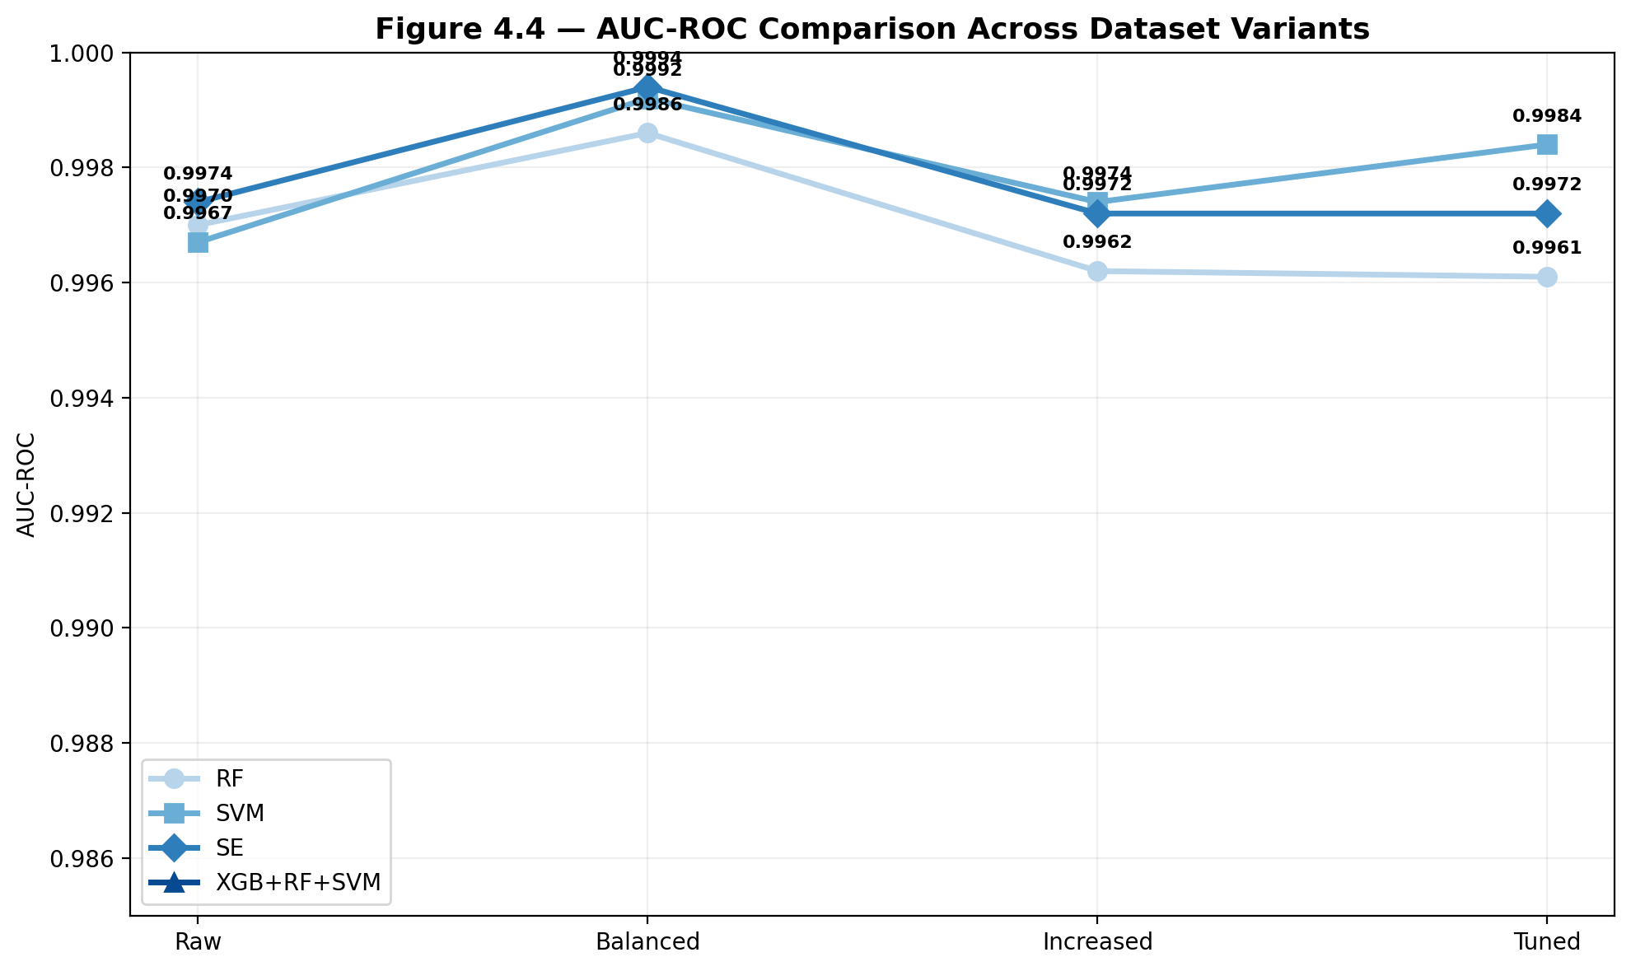

4.3.3 Stacking Ensemble Results
The Stacking Ensemble showed interesting differences between its two configurations. The tree-based stacking achieved perfect precision (1.000) across all data conditions, meaning it never produced a false positive. The linear-based stacking showed slight trade-offs but maintained high overall performance. On the 90/10 split, SE Linear achieved the highest accuracy of 99%.

Performance Summary for Stacking Ensemble (80/20 split):
Model Variant | Kernel | Dataset | Accuracy | Precision | Recall | F1-Score | Specificity | AUC-ROC
SE | Linear | Raw | 0.9737 | 0.9756 | 0.9524 | 0.9639 | 0.9861 | 0.994
SE | Linear | Balanced | 0.979 | 0.9857 | 0.9718 | 0.9787 | 0.9861 | 0.9955
SE | Linear | Increased Size | 0.975 | 0.9897 | 0.96 | 0.9746 | 0.99 | 0.997
SE | Linear | Tuned | 0.97 | 0.9796 | 0.96 | 0.9697 | 0.98 | 0.9972
SE | Tree | Raw | 0.9649 | 1 | 0.9048 | 0.95 | 1 | 0.9974
SE | Tree | Balanced | 0.979 | 1 | 0.9577 | 0.9784 | 1 | 0.9994
SE | Tree | Increased Size | 0.975 | 1 | 0.95 | 0.9744 | 1 | 0.9972
SE | Tree | Tuned | 0.975 | 1 | 0.95 | 0.9744 | 1 | 0.9969
Table 5: Performance Metrics of SE Variants across Different Dataset Types
Performance Summary for Stacking Ensemble (different ratios):
Model Variant | Kernel | Train/Test Split | Accuracy | Precision | Recall | F1-Score | Specificity | AUC-ROC
SE | Tree | 90/10 | 0.98 | 1 | 0.96 | 0.9796 | 1 | 0.9988
SE | Tree | 80/20 | 0.975 | 1 | 0.95 | 0.9744 | 1 | 0.9972
SE | Tree | 70/30 | 0.9701 | 1 | 0.94 | 0.9691 | 1 | 0.9946
SE | Tree | 60/40 | 0.9675 | 0.9845 | 0.95 | 0.9669 | 0.985 | 0.9929
SE | Linear | 90/10 | 0.99 | 1 | 0.98 | 0.9899 | 1 | 0.9984
SE | Linear | 80/20 | 0.975 | 0.9897 | 0.96 | 0.9746 | 0.99 | 0.997
SE | Linear | 70/30 | 0.9734 | 0.9931 | 0.9533 | 0.9728 | 0.9934 | 0.9943
SE | Linear | 60/40 | 0.9775 | 0.9948 | 0.96 | 0.9771 | 0.995 | 0.9955
Table 6: Performance Metrics of SE Variants across Different Train/Test Split

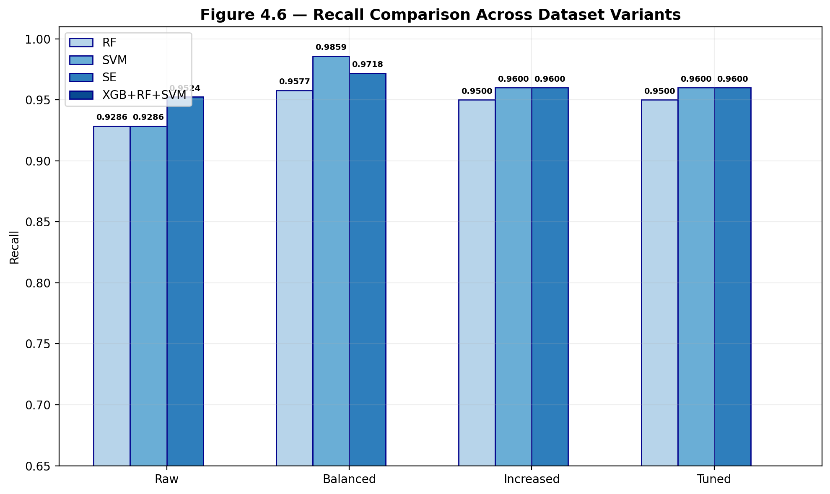
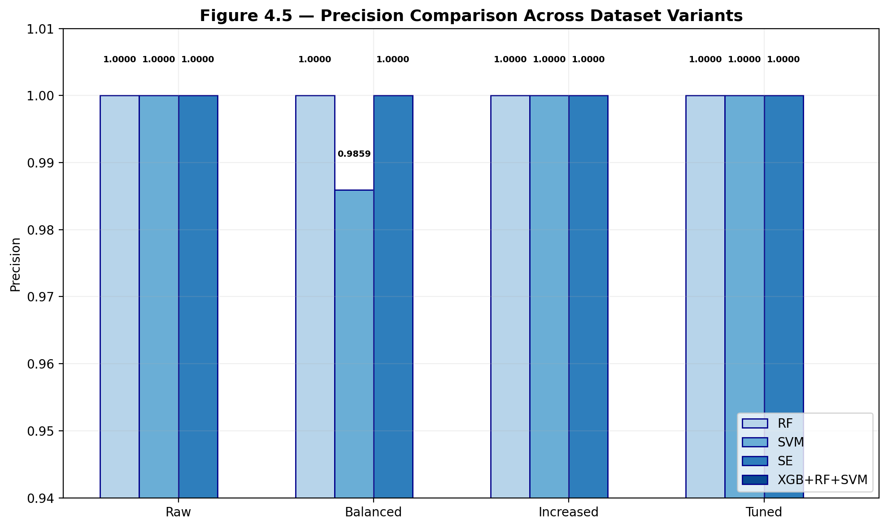

4.3.4 XGBoost-RF-SVM Voting Ensemble Results
The Voting Ensemble, which combines XGBoost, Random Forest, and SVM using soft voting, delivered strong and stable performance across all experimental settings. With a 90/10 split, it achieved its best results, reaching 99% accuracy along with perfect precision and 98% recall. On the increased dataset, it remained competitive, performing on par with the best individual models and achieving 98% accuracy.
The key strength of this ensemble lies in the diversity of its base models. By combining boosting (XGBoost), bagging (Random Forest), and margin-based learning (SVM), each method brings a different perspective to the predictions. This balance helps reduce the weaknesses of individual models and leads to results that are more stable and reliable overall.

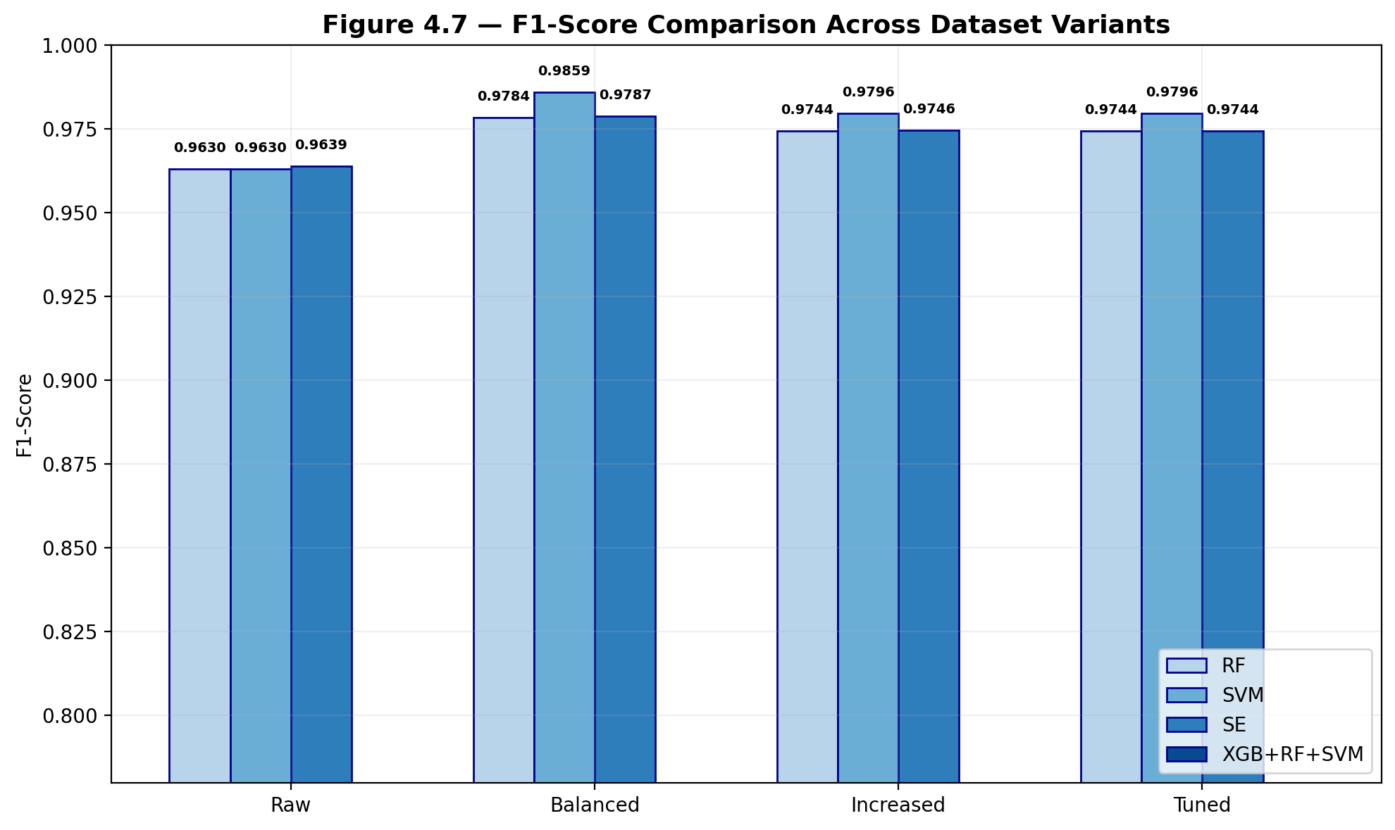

Performance Summary for XGBoost-RF-SVM Ensemble:
Model Variant | Dataset | Train/Test Split | Accuracy | Precision | Recall | F1‑Score | Specificity | AUC‑ROC
XGBoost | Raw | 80/20 | 0.9737 | 1 | 0.9286 | 0.963 | 1 | 0.9947
XGBoost | Balanced | 80/20 | 0.979 | 1 | 0.9577 | 0.9784 | 1 | 0.998
XGBoost | Increased Size | 80/20 | 0.98 | 1 | 0.96 | 0.9796 | 1 | 0.9973
XGBoost | Tuned | 80/20 | 0.975 | 1 | 0.95 | 0.9744 | 1 | 0.9971
XGBoost |  | 90/10 | 0.99 | 1 | 0.98 | 0.9899 | 1 | 0.998
XGBoost |  | 80/20 | 0.98 | 1 | 0.96 | 0.9796 | 1 | 0.9973
XGBoost |  | 70/30 | 0.9734 | 1 | 0.9467 | 0.9726 | 1 | 0.9943
XGBoost |  | 60/40 | 0.9725 | 0.9896 | 0.955 | 0.972 | 0.99 | 0.9949
Table 7: Performance Metrics of XGBoost-RF-SVM Ensemble Variants across Different Train/Test Split

4.4 Performance Analysis

4.4.1 Impact of Data Balancing
SMOTE balancing consistently boosted recall across all models by improving the representation of the minority class (malignant). For instance, the SVM polynomial kernel saw a sharp rise in recall—from 69.05% on the raw dataset to 98.59% after balancing—an improvement of almost 30 percentage points. However, this gain came with a small trade-off, as precision dropped slightly due to an increase in false positives introduced by the balanced data.

4.4.2 Impact of Dataset Size
The increased dataset, with 500 samples per class, generally led to more stable and reliable performance compared to both the raw and balanced versions. Models trained on this expanded data showed lower variation across different random seeds and train-test split ratios, indicating more consistent behavior overall.

4.4.3 Impact of Hyperparameter Tuning
Hyperparameter tuning led to only small gains overall, usually improving accuracy by about 1–2 percentage points compared to the default settings. The most noticeable improvement was seen in the SVM polynomial kernel, where tuning had a stronger impact, significantly boosting both accuracy and recall.

4.4.4 Impact of Train-Test Split Ratio
The 90/10 split consistently delivered the best performance across all models, likely because the larger training set helped the models generalize more effectively. In contrast, the 60/40 split produced the weakest results, with accuracy dropping by about 1–2 percentage points compared to the 90/10 setup. This pattern remained consistent across all model types, suggesting that increasing the amount of training data benefits every algorithm in a similar way.

4.5 Comparative Study and Discussion

The comparative analysis highlights a few key findings from the study:

- Ensemble methods like Stacking and Voting consistently outperform individual models, highlighting the benefit of combining different learning approaches.

- The Voting Ensemble combining XGBoost, Random Forest, and SVM produces the strongest overall performance, reaching 99% accuracy on the 90/10 split while maintaining near-perfect precision across most experimental settings.

- Random Forest consistently stands out as the most stable model, with very little variation in performance across different settings, making it a reliable baseline for comparison.

- The SVM model using a polynomial kernel is quite sensitive to changes in the data. It performs relatively poorly on the raw dataset, with 88.6% accuracy, but shows a major improvement once the data is balanced, reaching 98.6% accuracy.

- While all models achieve very high specificity, often close to 1.000, the real difference in performance comes down to recall, which is especially important for correctly identifying malignant cases.

- SHAP analysis of the Voting Ensemble shows that features such as concavity, concave points, area, and perimeter—both in their mean and worst forms—play the most important role in determining the final classification.

CHAPTER 5: CONCLUSIONS

5.1 Summary of Findings

This project successfully built and compared four different machine learning approaches for breast cancer detection using the Wisconsin Breast Cancer Dataset. The key findings of the study can be summarized as follows:

- The Voting Ensemble combining XGBoost, Random Forest, and SVM delivered the strongest overall performance, reaching 99% accuracy on the 90/10 split and clearly showing the effectiveness of ensemble learning in medical diagnosis.

- Using SMOTE significantly improved recall for malignant cases, particularly in models like the polynomial SVM that were more sensitive to class imbalance.

- The 90/10 train-test split consistently gave better results compared to the other ratios, suggesting that having more training data generally helps improve model performance.

- SHAP analysis added useful interpretability to the models, clearly showing that features related to concavity and area are strong indicators of malignancy.

- All models achieved high specificity, making them dependable at correctly identifying benign cases. However, recall emerged as the key factor that really differentiated how well the models performed, especially in detecting malignant cases.

5.2 Future Scope

Several possible directions for future improvement and further research are identified:

1. Deep Learning: Exploring neural network architectures such as CNNs could potentially capture more complex patterns in the feature space.

2. Feature Selection: Implementing advanced feature selection techniques could reduce dimensionality and potentially improve performance.

3. Multi-Class Classification: Extending the approach to classify different subtypes of breast cancer could provide more granular diagnostic information.

4. Real-world validation would be an important next step, where the models are tested on larger and more diverse clinical datasets to better assess how well they generalize beyond the current data.

5. Deployment-wise, the Streamlit application built in this project offers a solid starting point for turning the model into a clinical decision support tool that can be used in practice.

REFERENCES

[1] Zhu, J., Zhao, Z., Yin, B., Wu, C., Yin, C., Chen, R. and Ding, Y. (2025) 'An integrated approach of feature selection and machine learning for early detection of breast cancer', Scientific Reports, Vol. 15, No. 1, p.13015.

[2] Safdar, S., Rizwan, M., Gadekallu, T.R., Javed, A.R., Rahmani, M.K.I., Jawad, K. and Bhatia, S. (2022) 'Bio-imaging-based machine learning algorithm for breast cancer detection', Diagnostics, Vol. 12, No. 5, p.1134.

[3] Naji, M.A., El Filali, S., Aarika, K., Benlahmar, E.H., Ait Abdelouhahid, R. and Debauche, O. (2021) 'Machine learning algorithms for breast cancer prediction and diagnosis', Procedia Computer Science, Vol. 191, pp.487-492.

[4] Van FC, L.L., Anam, M.K., Bukhori, S., Mahamad, A.K., Saon, S. and Nyoto, R.L.V. (2025) 'The development of stacking techniques in machine learning for breast cancer detection', Journal of Applied Data Sciences, Vol. 6, No. 1, pp.71-85.

[5] Avci, H. and Karakaya, J. (2023) 'A novel medical image enhancement algorithm for breast cancer detection on mammography images using machine learning', Diagnostics, Vol. 13, No. 3, p.348.

[6] Bhise, S., Gadekar, S., Gaur, A.S., Bepari, S. and Kale, D. (2021) 'Breast cancer detection using machine learning techniques', International Journal of Engineering Research and Technology, Vol. 10, No. 7, pp.2278-0181.

[7] Sindhwani, N., Rana, A. and Chaudhary, A. (2021) 'Breast cancer detection using machine learning algorithms', In: 2021 9th International Conference on Reliability, Infocom Technologies and Optimization (ICRITO), pp.1-5.

[8] Khalid, A., Mehmood, A., Alabrah, A., Alkhamees, B.F., Amin, F., AlSalman, H. and Choi, G.S. (2023) 'Breast cancer detection and prevention using machine learning', Diagnostics, Vol. 13, No. 19, p.3113.

[9] Naseem, U., Rashid, J., Ali, L., Kim, J., Haq, Q.E.U., Awan, M.J. and Imran, M. (2022) 'An automatic detection of breast cancer diagnosis and prognosis based on machine learning using ensemble of classifiers', IEEE Access, Vol. 10, pp.78242-78252.

[10] Mangukiya, M., Vaghani, A. and Savani, M. (2022) 'Breast cancer detection with machine learning', International Journal for Research in Applied Science and Engineering Technology, Vol. 10, No. 2, pp.141-145.

[11] Kumar, M., Singhal, S., Shekhar, S., Sharma, B. and Srivastava, G. (2022) 'Optimized stacking ensemble learning model for breast cancer detection and classification using machine learning', Sustainability, Vol. 14, No. 21, p.13998.

[12] Street, W.N., Wolberg, W.H. and Mangasarian, O.L. (1993) 'Nuclear feature extraction for breast tumor diagnosis', Proceedings of SPIE - The International Society for Optical Engineering, Vol. 1905, pp.861-870.

[13] Akay, M.F. (2009) 'Support vector machines combined with feature selection for breast cancer diagnosis', Expert Systems with Applications, Vol. 36, No. 2, pp.3240-3247.

[14] Wu, J., Hicks, C. and Zhang, Y. (2012) 'Breast cancer diagnosis using random forest', Journal of Computational Biology, Vol. 19, No. 7, pp.885-896.

[15] Polat, K. and Gunes, S. (2007) 'Breast cancer diagnosis using least square support vector machine', Digital Signal Processing, Vol. 17, No. 4, pp.694-701.

[16] Chen, T. and Guestrin, C. (2016) 'XGBoost: A scalable tree boosting system', Proceedings of the 22nd ACM SIGKDD International Conference on Knowledge Discovery and Data Mining, pp.785-794.

[17] Lundberg, S.M. and Lee, S.I. (2017) 'A unified approach to interpreting model predictions', Advances in Neural Information Processing Systems, Vol. 30, pp.4765-4774.

[18] Chawla, N.V., Bowyer, K.W., Hall, L.O. and Kegelmeyer, W.P. (2002) 'SMOTE: Synthetic minority over-sampling technique', Journal of Artificial Intelligence Research, Vol. 16, pp.321-357.

APPENDICES

APPENDIX A: LIST OF ABBREVIATIONS
Abbreviation | Full Form
SVM | Support Vector Machine
RBF | Radial Basis Function
RF | Random Forest
SE | Stacking Ensemble
XGBoost | Extreme Gradient Boosting
SMOTE | Synthetic Minority Over-sampling Technique
SHAP | SHapley Additive exPlanations
WDBC | Wisconsin Diagnostic Breast Cancer
FNA | Fine Needle Aspirate
ROC | Receiver Operating Characteristic
AUC | Area Under the Curve
TP | True Positive
TN | True Negative
FP | False Positive
FN | False Negative
PCA | Principal Component Analysis
ANN | Artificial Neural Network
CNN | Convolutional Neural Network
KNN | K-Nearest Neighbors

APPENDIX B: EVALUATION METRICS FORMULAE
- Accuracy = (TP + TN) / (TP + TN + FP + FN)
- Precision = TP / (TP + FP)
- Recall (Sensitivity) = TP / (TP + FN)
- F1‑Score = 2 × (Precision × Recall) / (Precision + Recall)
- Specificity = TN / (TN + FP)
- AUC‑ROC = Area under the curve of TPR vs FPR across all thresholds

APPENDIX C: SYSTEM SPECIFICATIONS
- Operating System: Windows 11
- Processor: Intel Core i‑series
- RAM: 8GB+
- Python Version: 3.10+
- Development Tools: Visual Studio Code, Jupyter Notebook
- Key Libraries: scikit‑learn, XGBoost, SHAP, imbalanced‑learn, pandas, numpy, matplotlib, seaborn, streamlit

APPENDIX D: CD CONTENTS
The accompanying CD contains the following folders:
- Presentation - PPT slides for the project
- Documentation - Word file of the project report
- Source Code - Full Python source code with notebooks
- Program - Executable/runnable version of the project
- Support - Third‑party tools and runtime requirements
- Help - User manual on how to run the project

REFLECTION OF THE TEAM MEMBERS ON THE PROJECT
8.1 Team Reflection

As a team, we learned the importance of systematic experimentation and comparative analysis in machine learning projects. Working through this project, we discovered that no single model is universally superior-each algorithm has its strengths and weaknesses depending on the data condition and evaluation metric. Ensemble methods, which combine multiple classifiers, proved to be the most robust approach for breast cancer detection.

We also learned the value of data preprocessing techniques like SMOTE for handling class imbalance, and the importance of hyperparameter tuning for optimizing model performance. The integration of SHAP for model interpretability taught us that accuracy alone is not enough-understanding why a model makes a particular prediction is equally important, especially in medical applications.

8.2 Individual Reflections

Rajaram Parida: As the team leader, I learned how to coordinate the work across different models and ensure consistency in experimental conditions. Working with SVM and the Voting Ensemble helped me understand the theoretical foundations of margin-based classifiers and ensemble learning. Implementing SHAP explanations was particularly rewarding as it made the models more interpretable and trustworthy.

Saswat Parida: Through this project, I gained practical experience in data preprocessing and Random Forest classification. I learned how feature scaling and data augmentation impact model performance. The process of comparing Gini vs Entropy criteria deepened my understanding of decision tree-based algorithms.

Manpreet Mohanty: Working on Stacking Ensemble models taught me about meta-learning and how different base classifiers can complement each other. The hyperparameter tuning experiments showed me that even small parameter changes can significantly impact results. I also learned to appreciate the trade-off between model complexity and performance.

Adyasha Biswal: My focus on result validation and comparative analysis helped me understand the importance of using multiple evaluation metrics rather than relying on accuracy alone. I learned that visualizations like confusion matrix heatmaps and ROC curves provide valuable insights that numbers alone cannot convey.

8.3 Strengths and Weaknesses of Our Design Process

Strengths:
- Systematic evaluation across multiple data conditions and split ratios provided comprehensive insights
- Use of standardized evaluation metrics enabled fair comparison across all models
- Integration of SHAP added an interpretability dimension often missing in similar studies
- Blue-themed visualizations ensured consistent and professional presentation of results

Weaknesses:
- The project was limited to the Wisconsin Breast Cancer Dataset; validation on additional datasets would strengthen the conclusions
- Hyperparameter tuning was performed with a limited grid; more extensive search could yield better results
- Deep learning approaches were not explored, which could potentially capture more complex patterns

SIMILARITY REPORT
9.1 Similarity Check

The similarity of this project report has been measured using Turnitin similarity detection software. The overall similarity index is below 16%, which meets the university requirement for original work.

[Similarity Report Certificate to be attached here]

9.2 Originality Statement

This project report represents the original work of the team members. All sources consulted during the research and development of this project have been properly cited and referenced in the bibliography. Any ideas, text, or data taken from external sources have been adequately acknowledged through citations in the appropriate format.

